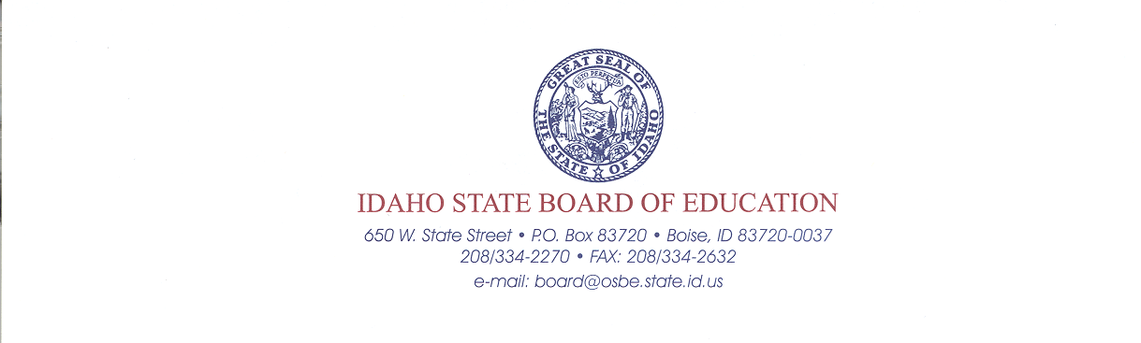<Insert Date>
www.boardofed.idaho.gov

www.boardofed.idaho.gov

<Insert Patron Name & Address>

Dear <Insert Patron Name>,

Welcome to a new school year. This letter details the <insert name of School District> progress toward state Reading, Mathematical, and Language Arts goals and reviews options available to some students.

Each year, all districts are required to reach goals in Reading, Mathematics, and Language Arts subject areas. Within those areas, districts must meet student performance targets in:

- Achievement,
- Growth to Achievement,
- Grothe to Achievement Within Subgroups,
- Postsecondary and Career Readiness, and
- Participation.

See the attached Adequate Yearly Progress/Star Rating Report for the district’s proficiency ratings. The full report is available from the State Department of Education at http://apps.sde.idaho.gov/ayp .

<Insert name of School District> is in <insert AYP status i.e., District Improvement Yr.> because <insert of sub groups> did not meet the academic targets in <insert category>. In keeping with the No Child Left Behind [NCLB] Law, the <insert name of School District> may have education options available for individual students. Feel free to consult the District Superintendent on these options.

Districts do not take missing any goal lightly. The district is committed to using the best strategies to help individual students. The goal is for all students to be successful. To that end, districts will be providing strategies to help children who struggle to improve, such as:

<insert strategies here, for example…
- The District has included a list of the strategies that they will be using to improve student achievement in the targeted areas.
- The SDE’s system of support to districts/ and schools in improvement is implemented by the Center for School Improvement at BSU. This includes workshops throughout the state in the fall to give assistance in best practices. Any district/school may contact the Center for School Improvement or the SDE for personal technical assistance.>

There are many ways that you can be involved in helping us address the issues around District Improvement. Below are some ways local patrons can become involved:

<Insert ways of involvement here>

Thank you for your time, interest, and attention on this issue.

Sincerely,
<Insert your signature, title, etc. here>

