**To Submit your Direct Admissions File to OSBE via OTIS:**

* Go the ISEE applications portal at <https://apps2.sde.idaho.gov/>
* Log on with your user name and password
* Once you’re logged in, you will see a list of available applications. Click on the “OTIS” icon

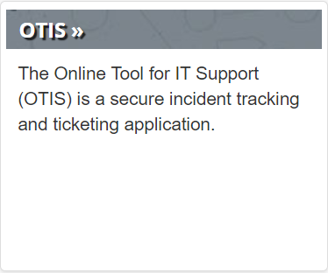

* If you do not see the OTIS icon, you need to have your permissions updated. You should have a district colleague who can assign permissions via the admin tool. If you need additional help, contact the State Department of Education’s support desk at [support@sde.idaho.gov](mailto:support@sde.idaho.gov) or (208) 332-6987.
* Once you’re logged in to OTIS, click on “Create A Ticket”

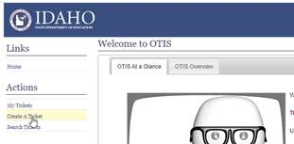

* Make sure your Requestor Information is correct
* For Priority, select **5 - Standard**
* For Ticket Type, select **Secure Information Submission**
* For Action/Issue, select **Documents**
* For Category, select **Direct Admissions**

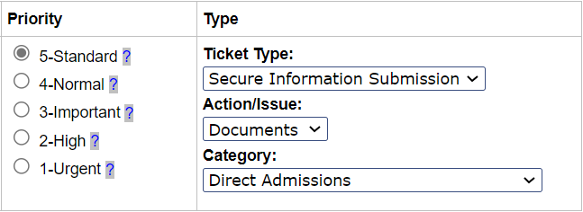

* In the summary line please enter your district number and PEBT

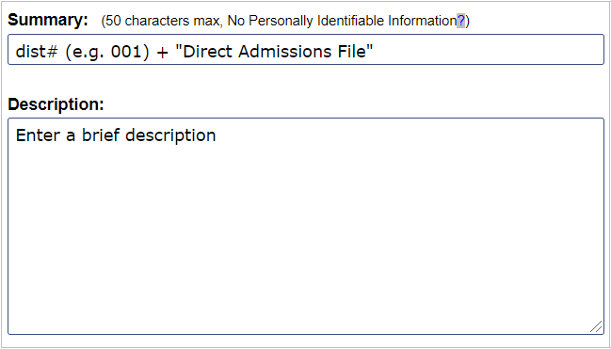

* Add the template saved as <**district number**_**DirectAdmissions**> using the “Add” button next to the “Attachments” heading

cid:image004.png@01D65937.96110720

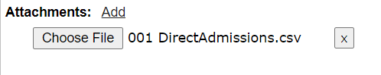

* When complete, click “Create Ticket”

